INVESTOR WEBSITE: FAQ’S & uSER gUIDE

Winslow Capital is pleased to provide an Investor Website (“IWS”) for parties with interest in accounts of its International Fund, LLC (the “Fund”), which is administered by The Northern Trust Company (the “Administrator”) on its behalf.

All Investor Website Inquiries should be directed to the Administrator:
Email: WinslowFunds@ntrs.com
Phone: Toll Free 1-855-351-4583
Business Hours: 8AM – 5PM CST

FREQUENTLY ASKED QUESTIONS

How do I gain access to Investor Website?
To be registered as an Investor Website User you must be listed as the legal owner or interested party with interests in accounts of the Fund. When an interested party’s email address has been entered in the Fund’s administration register to receive documents, that email address will be used to create an IWS user account.

For further details on gaining access to Investor Website, please contact the Administrator using the contact details provided above and or via the ‘Contact Us’ details accessed from the upper-right corner of the Log On page.

How can I unlock my Investor Website account?
If a user receives a message that their account is locked, it may be necessary to contact the Administrator using the contact details provided above or via the ‘Contact Us’ details accessed from the upper-right corner of the Log On page. In most cases, the Administrator will initiate the re-registration of the user account.

How can I add an alternate email address to receive notifications from IWS?
Through the initial email registration or by editing your security settings, you may update an additional email address to receive automated notifications from the Investor Website.

To update an additional email recipient to Investor Website Notifications after your account has been registered, click on the ‘Settings’ button located in the Investor Information Section to access your Security Profile. There you may add an additional email to receive notifications from the Investor Website.

For further details, refer to User Guide Information section 2.2.1 below.

How can I stop receiving email notifications from Investor Website?
Through the initial email registration or by editing your security settings you may update your Investor Website Security Profile to disable Email Notification. For further details, refer to User Guide Information section 2.2.1 below.

How can I access a historical statement?
Only documents loaded within the last 30 days will be displayed in the Documents/Statements Section of your Landing Page. The Document Search function allows you to search for historical documents previously loaded to your Investor Website account. For further details, refer to User Guide Information section 2.2.2 below.

How can I change my email address?
If your email address has changed please contact the Administrator using the contact details provided above or via the ‘Contact Us’ details accessed from the upper-right corner of the Log On page, to update your investor or interested party contact details. Once an email address for an existing recipient has been updated, your Investor Website account will be re-registered.

How can I change my security questions or contact phone number?
Once successfully logged into the Investor Website you may update your security questions by selecting Settings, then Security Profile Update. Your security questions and contact phone number are displayed and available for edit from this view. For further details, refer to User Guide Information section 3.4 below.

How can I change my password?
You may change or reset a forgotten password from the Investor Website Log On page. Upon authentication, you will be able to change your password. For further details, refer to User Guide Information section 3.2 below.

How can I login if I cannot remember my security questions?
You may select Security Code via Text or Voice in lieu of answering security questions. Upon authentication and access to Investor Website, you may update your security questions. For further details, refer to User Guide Information section 2.1.2 below.

If you have forgotten your security questions and your contact telephone number has changed, you will need to contact the Administrator, who after verifying your identity will in most cases need to initiate the re-registration process for the user account.

USER GUIDE INFORMATION

Registration

1.1 IWS User Account Creation
The Administrator will provide approval to initiate the registration process for the Interested Party (“IP”).

The IP will receive an email to their registered email address providing an IWS User ID.

Sample User ID email:
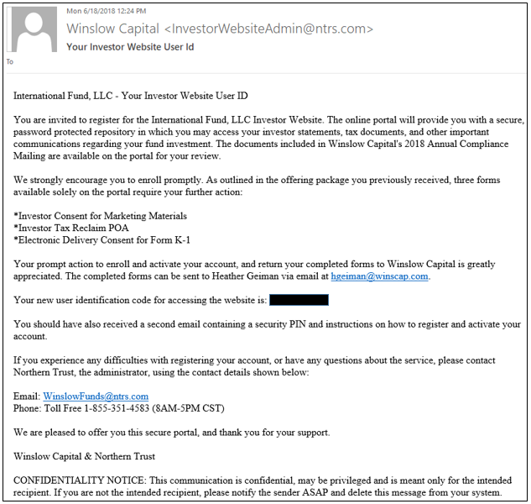

1.2 PIN Generation
The IP will receive a second email notifying them of a PIN number to be used in the registration process together with a ‘Register Link’.

Sample PIN notification email:
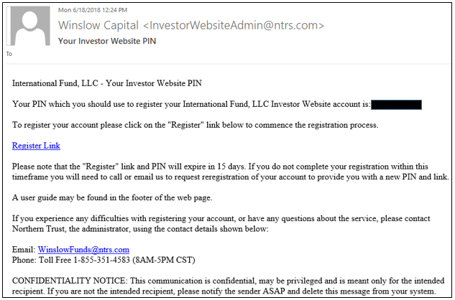

1.3 Email Registration Process
Clicking on the ‘Register Link’ will open the IWS email registration page in the user’s default web browser. Please note that IWS currently supports Internet Explorer 11 and Google Chrome.
If the IP is a group email address, it is the responsibility of the IP to administer and control access to their User ID, password and security questions and answers.

Sample Email Registration page:
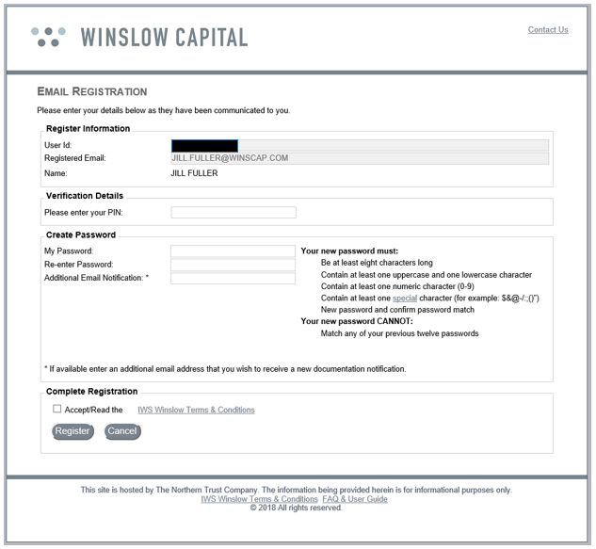

1.3.1 PIN Entry
The user should enter the PIN provided in the PIN notification email in the relevant box.

1.3.2 Create Password
The user should enter a password which is at least eight characters long, contains at least one uppercase and one lowercase letter, one numeric character (0 to 9) and one special character. The allowed special characters can be viewed by hovering on ‘special’.

Once entered, the user is required to re-enter the password to ensure it is correct.

1.3.3 Additional Email Notification
The user has the option to add an additional email address to receive notifications.

1.3.4 Complete Registration
To complete the registration process, the user must accept the website’s Terms and Conditions by clicking in the box provided. Users have the option to Open and Save the Terms and Conditions document, should they wish.

Once the user has accepted the Terms and Conditions, the user should click on the ‘Register’ button.

If the data has been entered successfully, the user will see the page shown below:
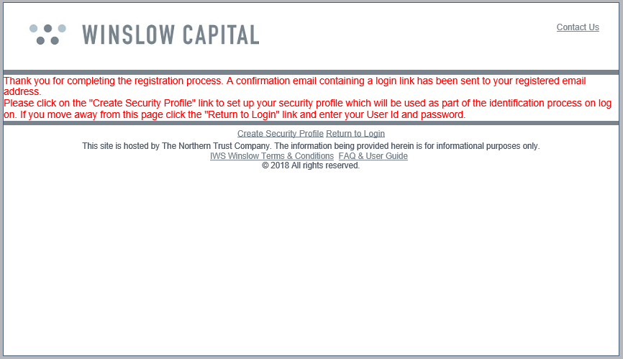

1.3.5 Create Security Profile
The user has the option of creating their security profile from the page shown above by clicking on the ‘Create Security Profile’ link. Users also have the option of completing this step following receipt of the Account Registration Email. The security profile consists of contact information and security questions.

For the security questions, the user will select six different security questions and provide suitable answers. Answers are not case sensitive, but only accept alphanumeric, hyphen (-), underscore (_) and space characters. Once the email address has been confirmed, and phone numbers and security question answers have been entered, the user should click the ‘Next’ button.

Sample Security Profile page:
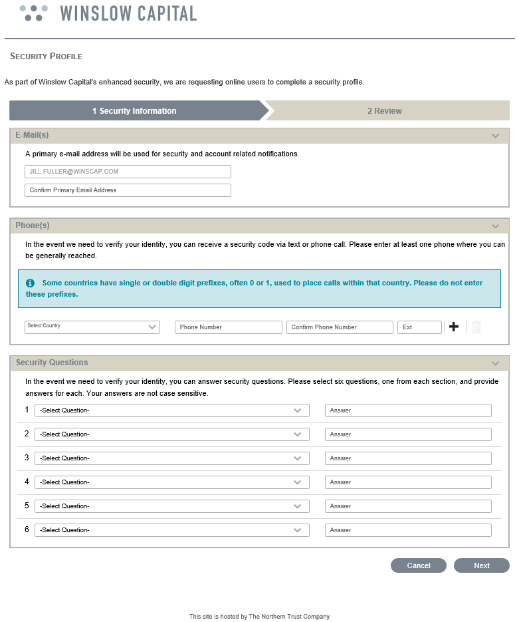

The user will then be provided with an opportunity to review their security profile before finalizing.

Clicking on ‘Show Answers’ will reveal the answers entered. Answers may be amended or different questions selected by clicking on the ‘Previous’ button. Clicking the ‘Cancel’ button takes the user back to the ‘Log On’ page. Once the user is satisfied with the selected questions and answers, they should click on the ‘Submit’ button.

Sample Security Profile review page:
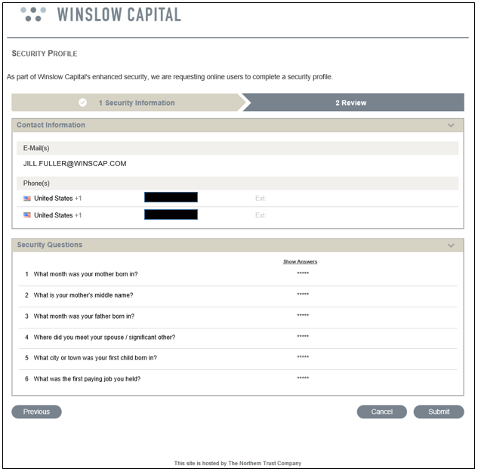

Upon successful creation of the user’s security profile, the following message will pop up in a new window:
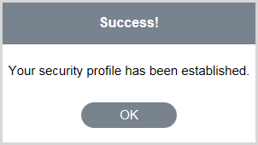

1.4 Account Registration Email
Upon successful registration, an email is sent to the user’s registered email address providing a ‘Login Link’.

Sample Account Registration email:
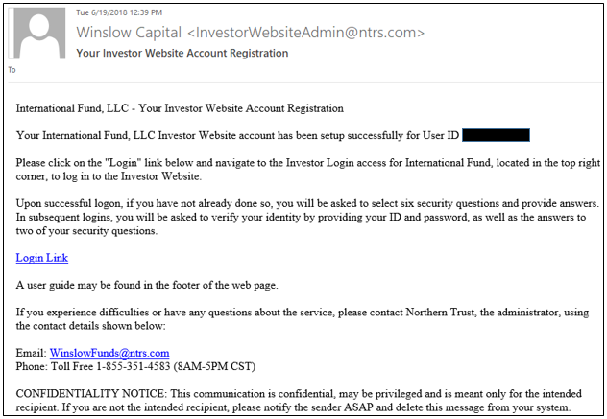

Logging On
Clicking on the ‘Login Link’ will open the Winslow Capital home page in the user’s default web browser. The user should navigate to the top right corner of the website, click on Investor Login, and select International Fund Investor Login: 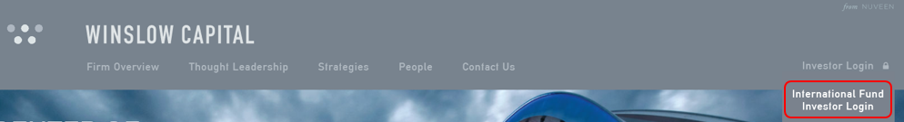

After clicking on International Fund Investor Login, the user will see a pop-up message indicating they are leaving Winslow’s website; the user should click the ‘Proceed’ button to be re-directed to the Northern Trust IWS investor portal:
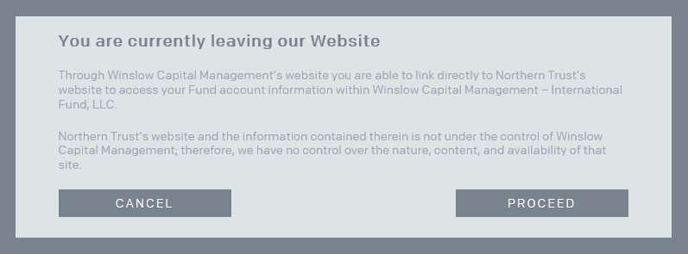

*Note: Users are unable to bookmark/favorite the Northern Trust IWS investor portal URL – the portal must be accessed via the Winslow Capital website.

Clicking the ‘Proceed’ button will open the IWS ‘Log On’ page in the user’s default web browser.

Sample Log On page:
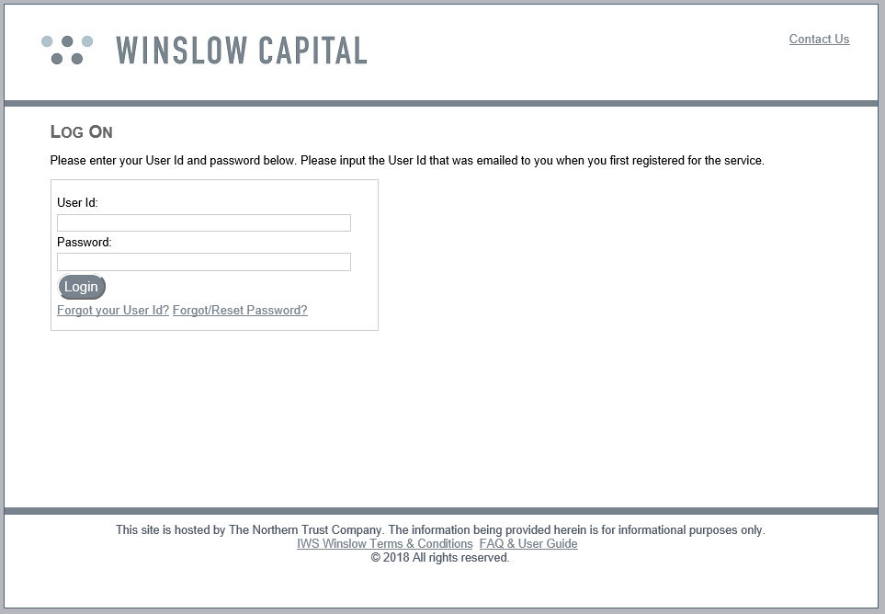

The user should enter their IWS User ID and password that was created during the registration process and click the ‘Login’ button.

2.1 Identity Verification

2.1.1 Security Profile Not Created
If the user’s security profile was not created during the registration process, upon successfully logging in, the Security Profile page will be displayed. The user should complete their security profile (see User Guide Information section 1.3.5 above).

Once successfully completed, the user will be presented with their landing page.

2.1.2 Security Profile Already Created
If the security profile was already created during the registration process and the login is successful, the user will be taken to the Verify Identity page. There will be two options to verify identity, ‘Request a Security Code via Text or Voice’ or ‘Answer Security Questions’.

Sample Verify Identity - Security Code via Text or Voice:
Select the option to receive a security code via Text or Voice. The phone number provided during your registration process will be used.
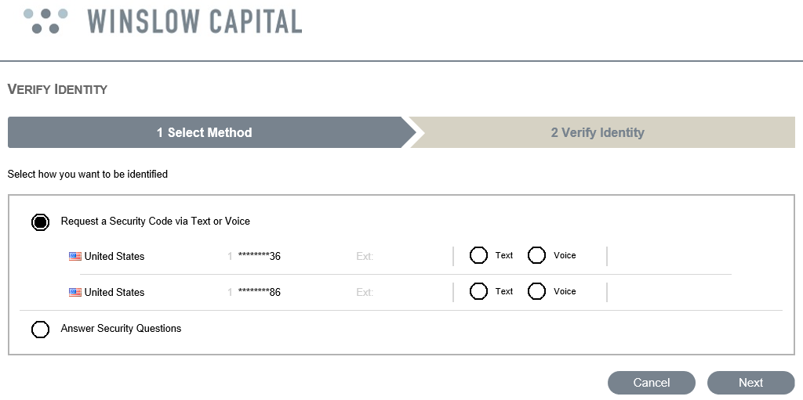

A security code will be sent to the phone number provided by text or voice. Enter the security code and click the ‘Done’ button.

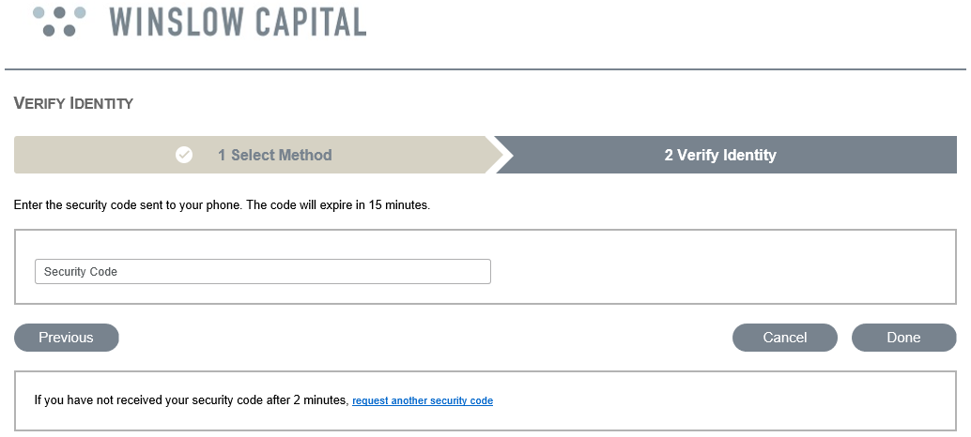

Sample Verify Identity – Answer Security Questions:
Select the option to Answer Security Questions.
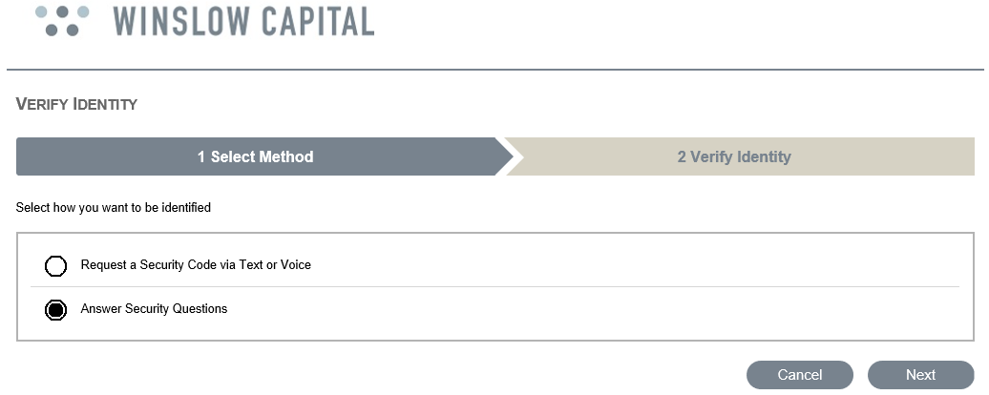

The user will be required to enter answers to two of the six security questions, clicking the ‘Done’ button when complete. The user will then be presented with their landing page.

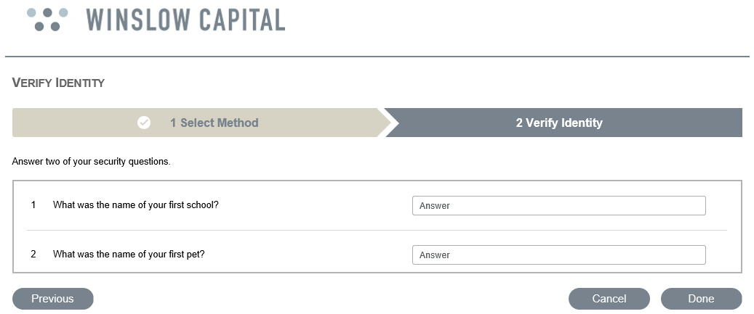

2.2 Landing Page
If the login is successful, the user’s landing page will be displayed.

Sample landing page:
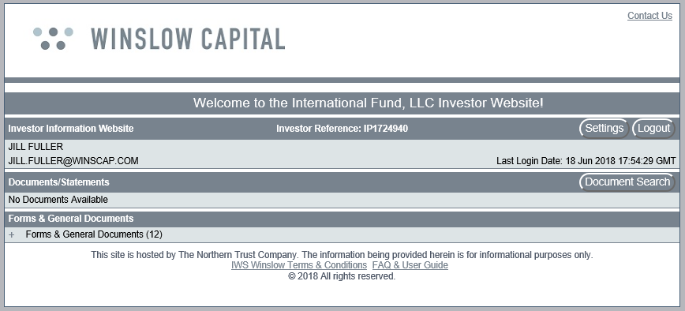

2.2.1 Investor Information Section
This section shows at a minimum:
- The user’s investor website ID, which was provided prior to registration
- The user’s registered email address
- The date and time the user last logged in

Settings Button
Clicking on the ‘Settings’ button shows the ‘User Settings’ page where the user can change the questions and answers to the security questions that were provided during registration.

To change the security questions and answers, it is necessary to first click on the ‘Reset Security Questions & Answers’ box.

Users also have the option to unselect the ‘Email notification when new documents are available’ box, if the user does not wish to be notified of the availability of new documents.

If not completed during the registration process, the user can add an additional email address to which email notification will be sent when new documents become available.

Clicking the ‘Save’ button saves the changes that have been made.

Clicking on the ‘Home’ button returns the user to the landing page.

Log Out Button
Clicking on the ‘Logout’ button logs the user out and returns the user to the ‘Log On’ page.

2.2.2 Documents/Statements Section
This section shows the account related documents that are available.

Latest Documents
Clicking on the + sign next to a document type will expand the section to show all documents that were made available within the last 30 days. If the latest document was made available prior to the last 30 days, it will not be displayed.

Document Search
Clicking on the ‘Document Search’ button opens the Document History Search window. This search window provides the ability to search using different date ranges and document types. Once the relevant criteria have been input, the ‘Search’ button should be clicked.

If there are no documents available for the search, a message will be displayed indicating ‘No Documents Available’.

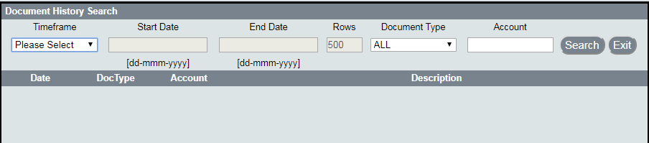

Document Retrieval
When using Internet Explorer, clicking on the date of a document will give the user the option to ‘Open’ or ‘Save’ the document.

Clicking on the arrow next to ‘Save’ gives the user the option to ‘Save’, ‘Save as’, or ‘Save and open’.

If using Chrome, the document is shown in the bottom left corner of the screen. Clicking on the arrow next to the document gives the user the option to ‘Open’, ‘Always open with system viewer’, ‘Open with system viewer’ and ‘Show in folder’.

The document will open in a separate window.

Problems Logging In

3.1 Forgot User ID
If a user has forgotten their User ID, they can obtain it by clicking on the ‘Forgot your User Id’ link on the Log On page:

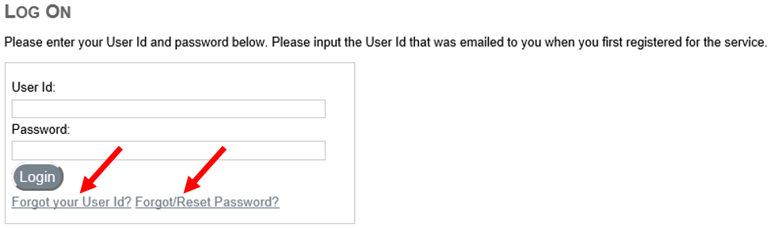

This will open the Forgot User ID page. The user should enter their IWS registered email address in the box provided and click the ‘Send’ button.

Once submitted, if the email address matches the registered email address, a message will be displayed stating that the User ID has been emailed.

The email generated will contain details of all User IDs associated with the registered email address provided.

3.2 Forgotten Password
If a user has forgotten or wishes to change their password, they can reset it by clicking on the ‘Forgot/Reset Password’ link on the Log On page. This will open the Reset Password page.

After entering their User ID and clicking on the ‘Answer Questions’ button, the Verify Identity page will open.

The user will be presented with two of the six security questions, which were set up during the registration process, and provide answers. The user should then enter and confirm a new password and click the ‘Reset’ button.

If the answers to the security questions match those provided during registration and the password complies with the password content requirements (see User Guide Information section 1.3.2 above), the password will be reset.

A message will be displayed confirming the password has been reset.

3.3 Forgotten Password AND Security Question Answers
When a user forgets their password and cannot remember their answers to the security questions that were selected during registration, it will be necessary to contact the Administrator using the contact details accessed from the Log On page.

Once the user has passed the security checks, the Administrator will initiate the re-registration process, which will require the user to perform the registration process again.

3.4 Changing Security Questions and Answers
If a user wishes to change either their security questions and/or answers, they can change them by logging on and clicking the ‘Settings’ button (see User Guide Information section 2.2.1 above).

3.5 Locked Account
If a user receives a message that their account is locked, it may be necessary to contact the Administrator using the contact details accessed from the Log On page, who will in most cases need to initiate the re-registration process for the user account.

3.6 Inactivity
An account will be locked if a user does not log in to their account for a period of 180 days or more. The user will receive the message “Account locked due to inactivity, please re-set your password.”

3.7 Incorrect Password/Security Answer Attempts
If a user enters their password or security question answers incorrectly three times, it will be necessary to contact the Administrator using the contact details accessed from the Log On page, who will in most cases need to initiate the re-registration process for the user account.

3.8 Malware
An account will be locked if Malware is detected on a user’s computer. Malware is a collective name for malicious software used by fraudsters to gain access to information on a computer. There are many forms of malware such as Trojans, Spyware and Viruses. If your account is locked due to the existence of malware, it will be necessary for the user to arrange for the malware to be removed.

